Hello, today, as always we will talk about another one of my projects. Number guessing game

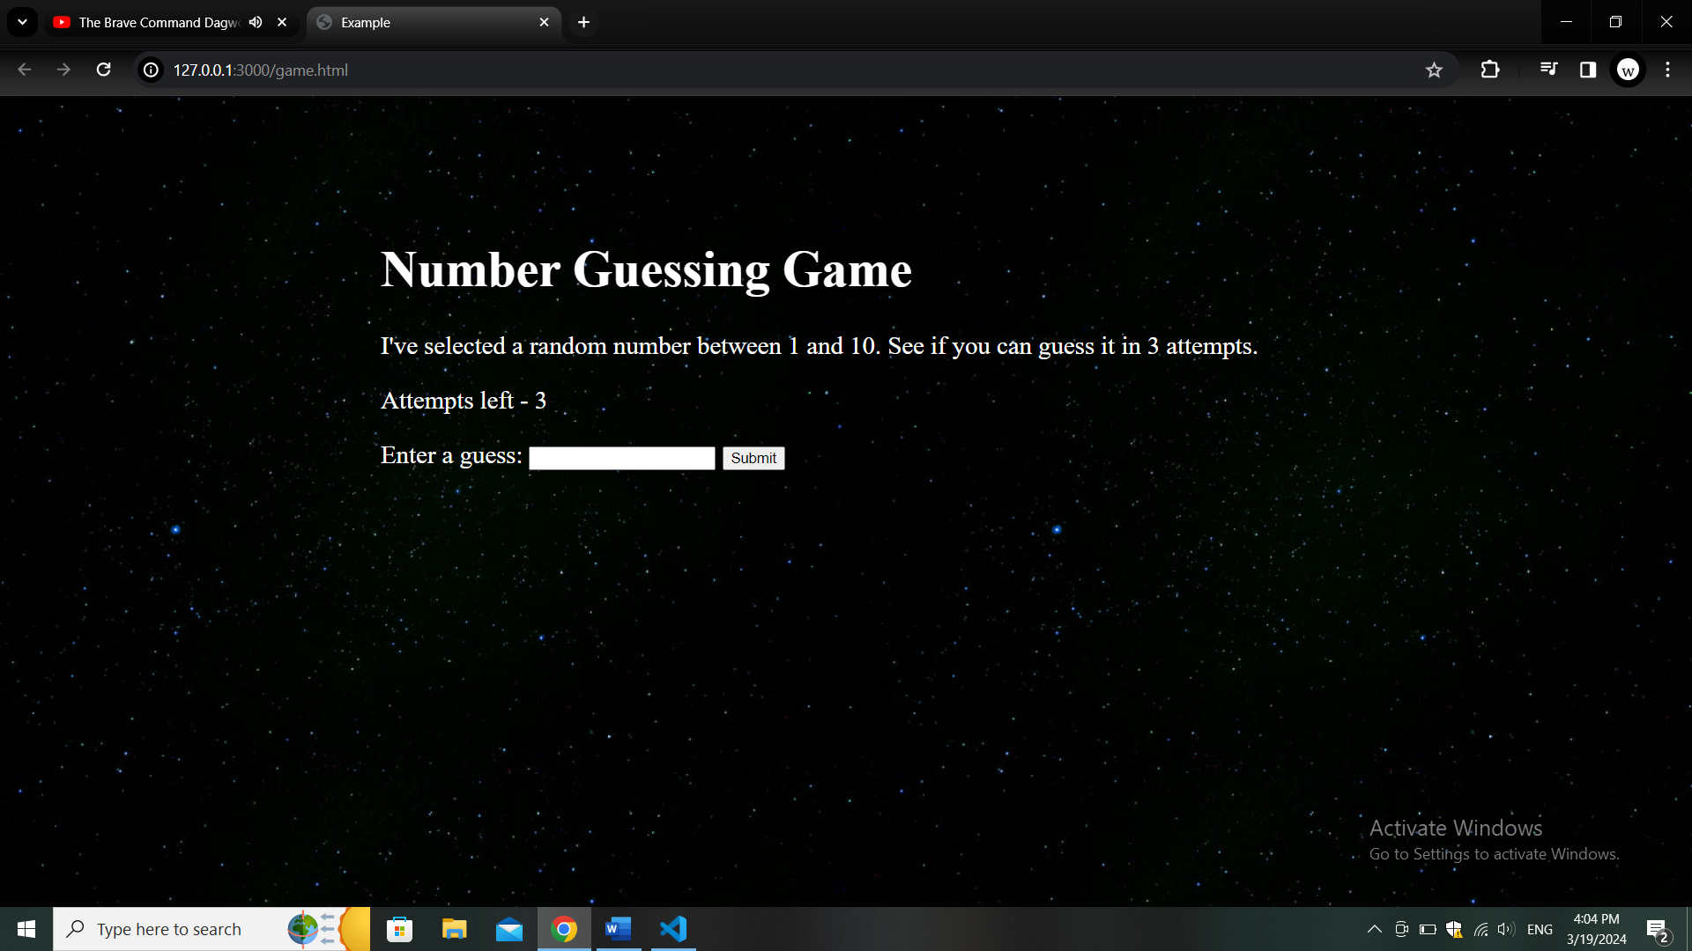

Well, on the image we have our interface, and we will go through how I created all of this using HTML, CSS and JS. First our root HTML that looks like this

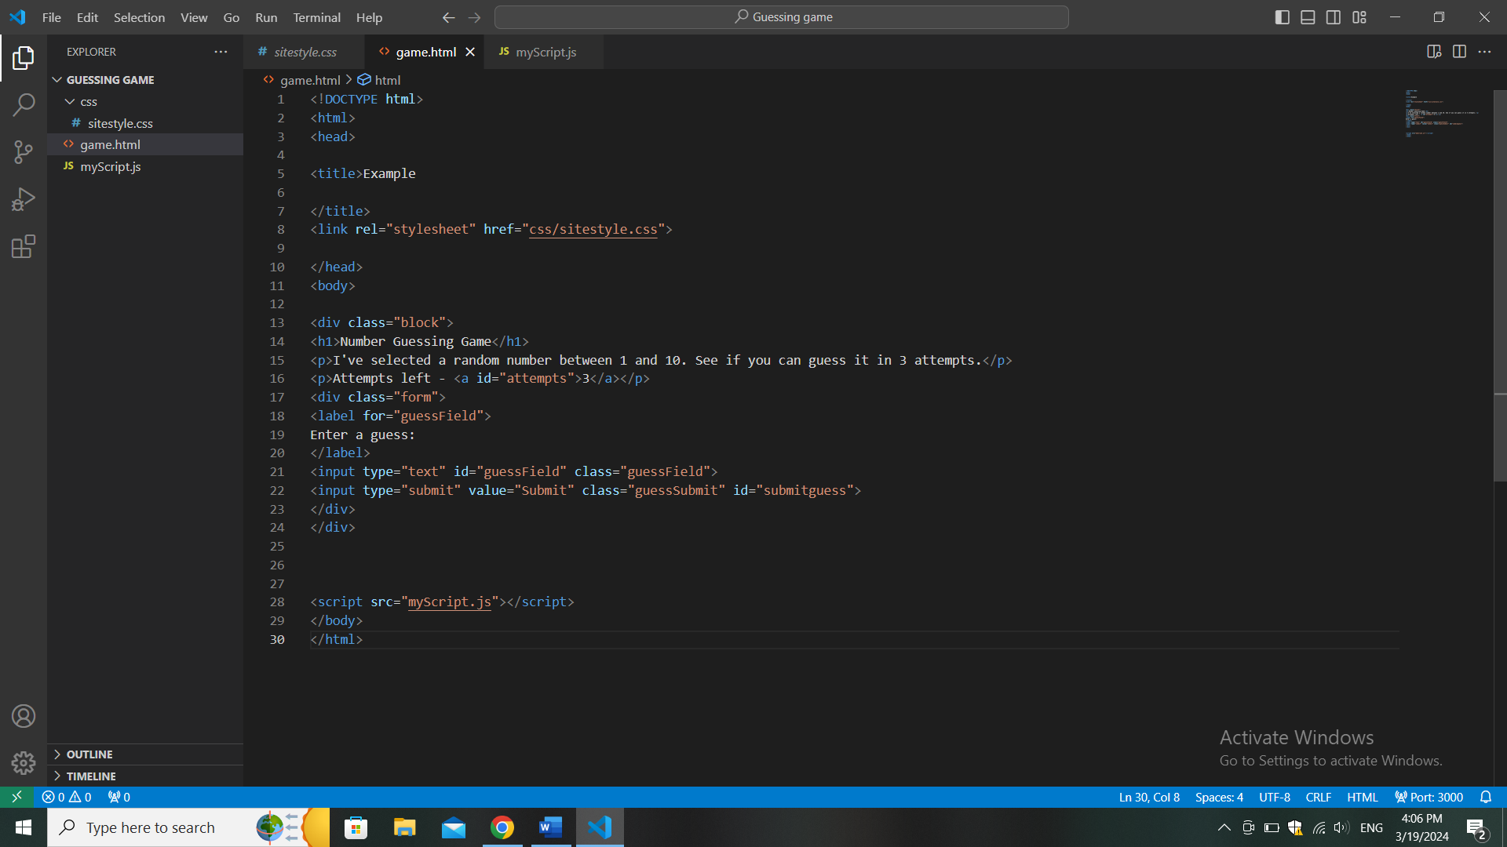

Nothing unusual, just our text in containers and ID’s and two inputs, one for inputing numbers, the other just a button for submitting our answer

Then our CSS, again, nothing out of ordinary

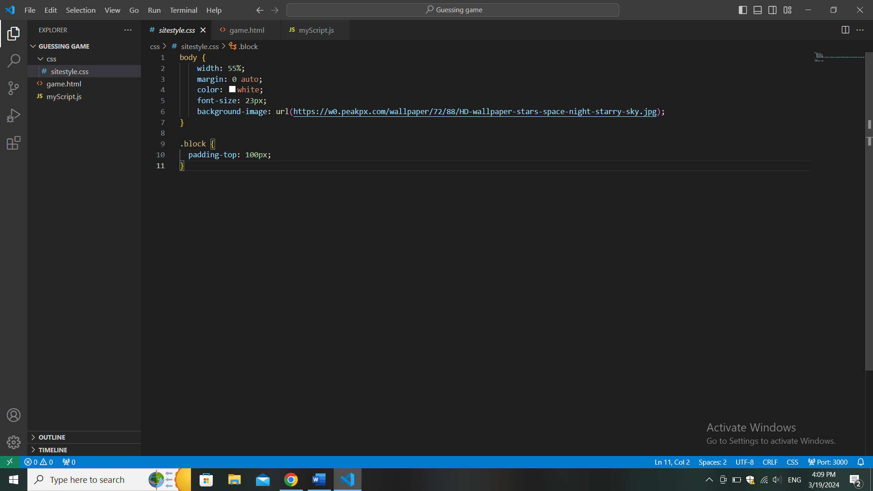

The true magic is in our JavaScript. Where first we make Y variable that computer itself is choosing randomly using included math function and our “guess” variable we equal to 1 to later increase it as an inside counter

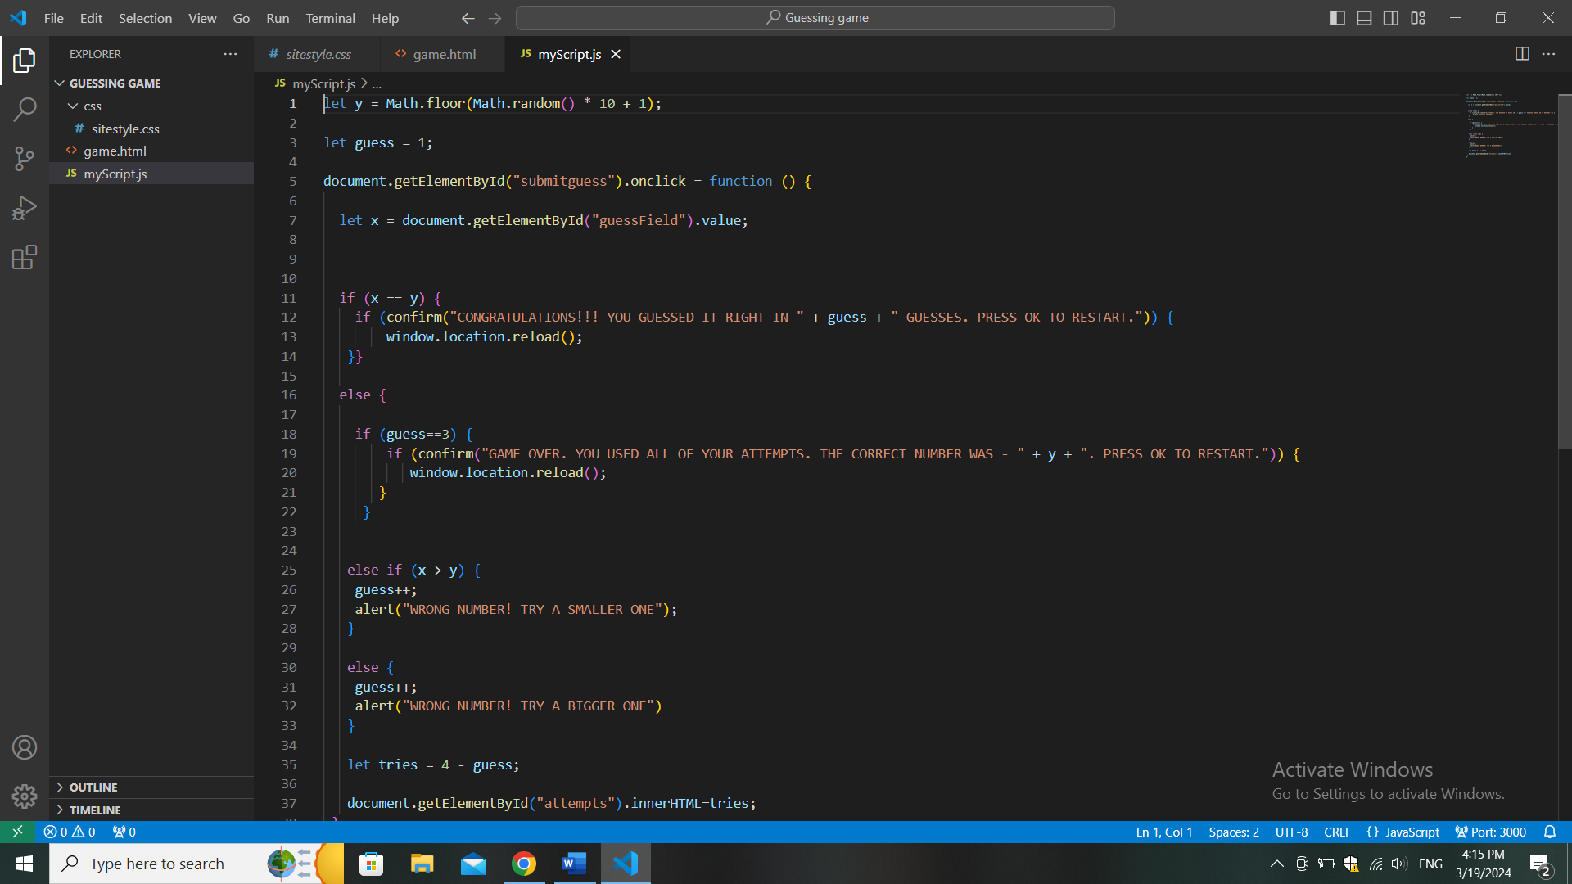

Then we make block in which further functions will be executed based on a click of our “submit” button

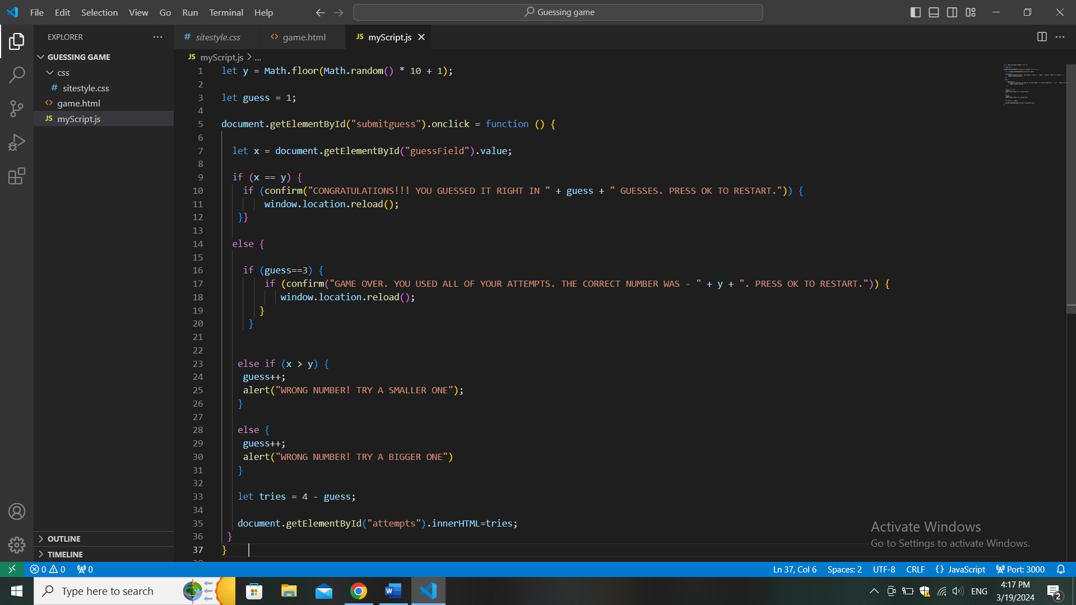

Inside first we make our x variable which is defined by the user inputing the number himself



Second thin we’ll do is we will make our system of attempts so we will have limited guesses. Just make our used attempts equal our desired amount minus our guesses, and we will show attempts by using innerHTML function

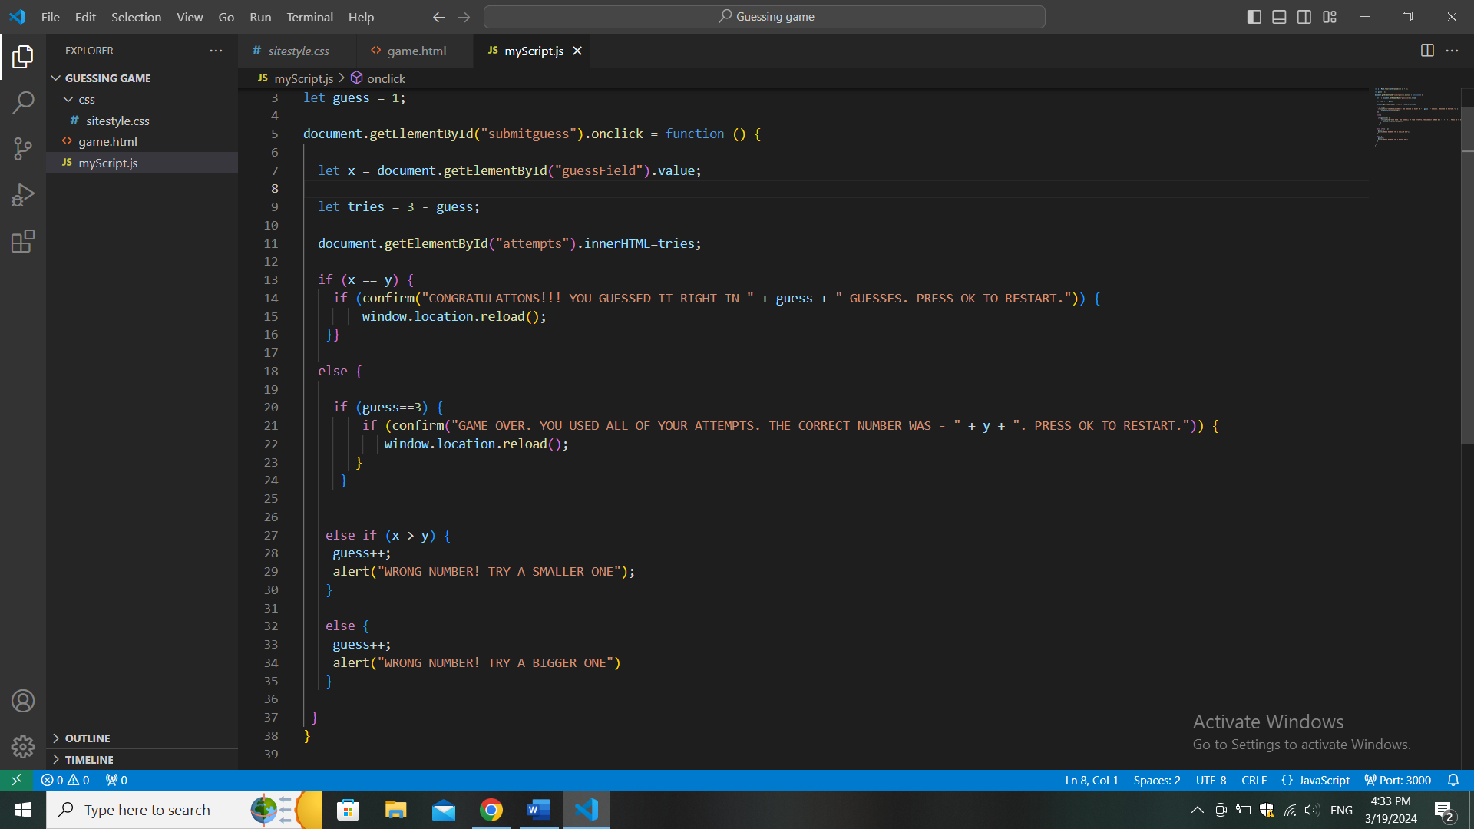

Then we make our check of winning (by guessing the number) and losing(by using up all of your attempts), using If else commands where we use “confirm” pop ups to then restart game or not {that is exexuted by using “reload” function that reloads page by pressing “ok” in the pop up)



In site itself it looks like this

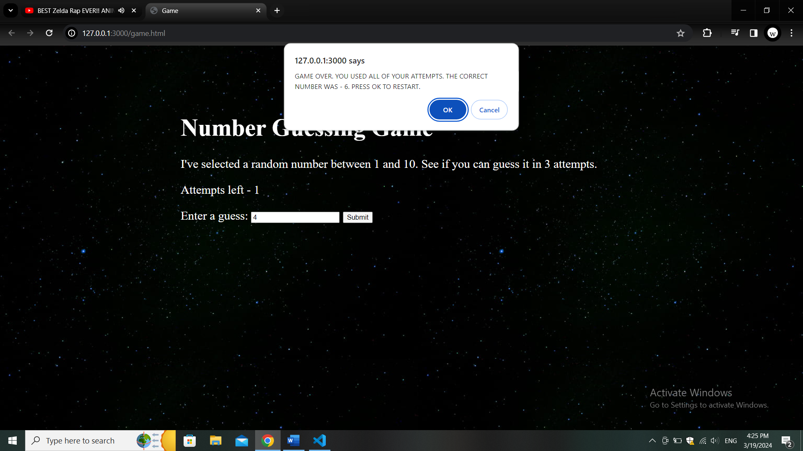

Then of course you will not win on a first attempt so we need to make a pop up(this time “alert”, because we don’t need user to choose anything and only displaying information) which says that inputed number is wrong and based on whenever it is bigger or smaller that Y, it determines whether user need to input bigger or smaller number. Also it makes our amount of guesses bigger by 1 every time



In site itself it looks like this

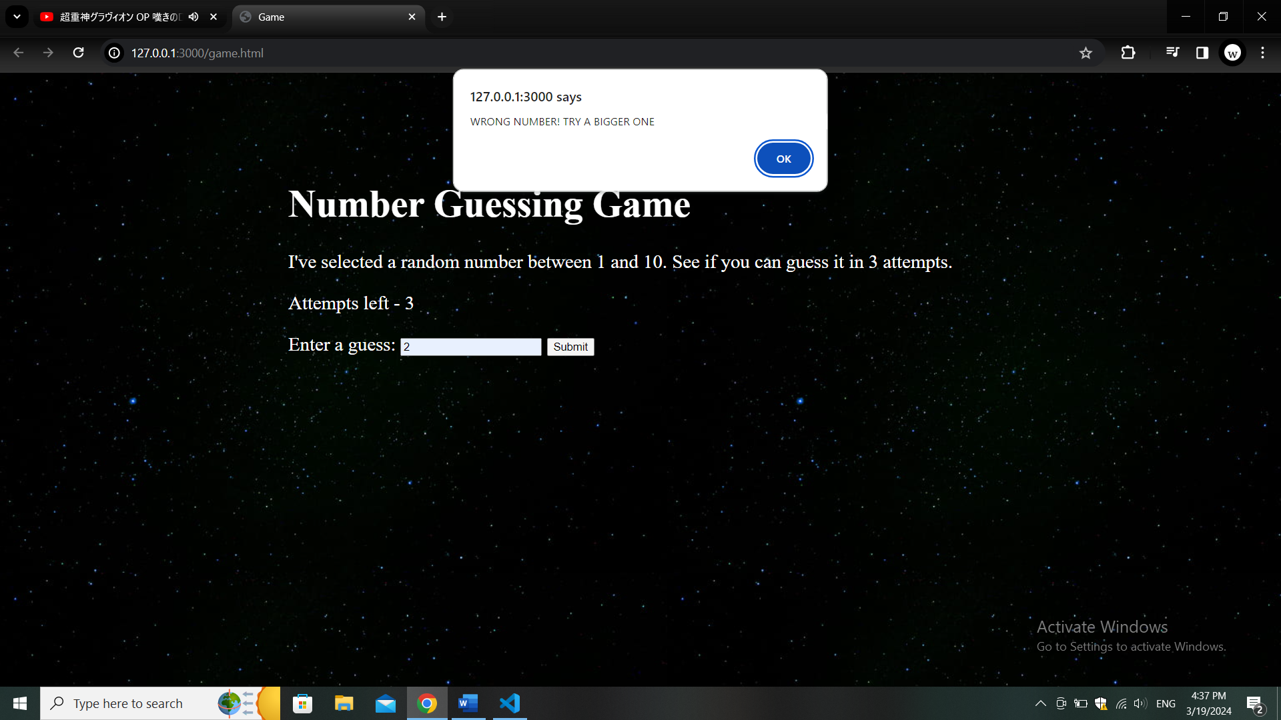

And that’s it, no more secrets there